Bachelor of Science in Health Science

Student Handbook
2017 - 2018

School of Health Technology and Management
Health Sciences Center
Stony Brook University
Stony Brook, New York 11794-8200

A Message from the Program Director...

Educating health care professionals has been a mission of Stony Brook University (SBU) since 1963 when the Muir Commission recommended that an academic health center be located on campus to address regional health care shortages. Forty-nine years later, our institution remains steadfast to this mission by developing the Health Science major in the School of Health Technology and Management. Our motivations and rationales for developing the major were to educate SBU students about the varied roles in allied health care. We also felt an enormous obligation to respond to regional workforce shortages and dwindling enrollments in many of our nation’s educational majors.

The Health Science major is a four-year program that begins with three years
of guided liberal arts study on SBU’s main campus. Students then join the School of Health Technology and Management in the fall semester of their senior year, taking a variety of courses that prepare them for entry-level jobs in non-clinical and clinical areas of health care. In less than five years, the major became the third largest major on campus. Our first graduating class, comprised of a modest thirty students, is no match for the 1000+ students currently working toward completing our major.
In addition, the Health Science major also offers affordable tuition, personal attention, multidisciplinary learning, close ties to a major teaching hospital, superior research and a superlative computer training center. You won't get lost in the crowd here. Although we are part of a large university, you will find that being part of the School of Health Technology and Management feels more like attending a small school or, as we prefer to think of it, being part of a close-knit family.
My staff and I look forward to welcoming you into our academic community. If you have any questions, please email me at deborah.zelizer@stonybrook.edu .

Sincerely,
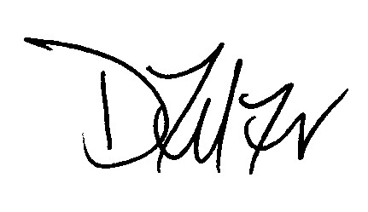

Deborah Zelizer, PhD, LCSW
Chair Health Science
Program Director of the Health Science Major
Health Science Program 631.444.6158
deborah.zelizer@stonybrook.edu

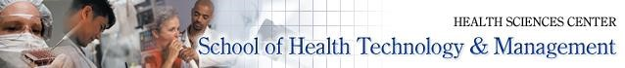

Mission: School of Health Technology and Management

The mission of the School of Health Technology and Management is to provide the health care field with the most qualified, innovative and caring professionals possible by teaching them in the most effective ways imaginable.

SHTM graduates are not only highly competent but compassionate practitioners – ever-mindful of the fact that preserving and maintaining the health and comfort of their fellow human beings is not only a responsibility, but a privilege.

As health care continues to evolve and improve, our school is committed to being a place where undergraduates and graduates alike can enhance their knowledge and skills - all in a quest for ways to effect change for the better in the health care industry.

Mission: Health Science major
The mission of the Health Science major is to provide the highest quality undergraduate education that integrates the principles of scholarship, ethics, cultural competency, communication skills, critical thinking, evidence-based practice, and civic orientation to meet the diverse regional needs of the evolving health care industry.
Program Goals:
- We utilize experiential learning communities that integrate opportunities for collaborative and active learning to improve student learning outcomes.
The learning communities model require that students integrate knowledge, skills, and competencies across the curriculum. For example, writing and APA formatting skills developed in HAN 383 should be utilized in all other courses a student is enrolled during the fall and spring semester.
- We promote the values of ethical, competent, and compassionate health care.
- We develop critical and independent thinking skills through the utilization of evidence-based teaching techniques and the implementation of emerging educational technologies.
- We provide students with knowledge and skills to enter the healthcare workforce, pursue graduate education, or secure professional opportunities in health care through rigorous scholarship, self-discovery, teamwork, evidence-based practice, and leadership.

Program Learning Outcomes: Students will demonstrate the ability to:
- Actively engage in scholarship by developing original research problems, applying research designs and methods, and communicating those ideas in research writing
- Integrate and apply requisite discipline specific knowledge, skills, competencies, ethical and professional values in a chosen healthcare field.

- Use evidence in critical thinking, problem solving, and decision making processes.

- Work collaboratively in diverse teams.

- Effectively communicate by demonstrating proficiency in written and oral communication skills.

Faculty and Staff Directory

Department Chair
Debbie Zelizer, PhD, LCSW
HSC, Level 2, Room 418
Phone: 631.444.6158
deborah.zelizer@stonybrook.edu

Assistant to the Chair
Jose Mejia, BS
HSC, Level 2, Room 472
Phone: 631.638.0987
jose.f.mejia@stonybrook.edu

Assistant Director of Academic Advising
Traci Thompson, MS
HSC, Level 2, Room 453
Phone: 631.444.2407
traci.thompson@stonybrook.edu

Academic Advisor
Jennifer Jimenez, MS
HSC, Level 2, Room 479
Phone: 631.444.6349
jennifer.jimenez.1@stonybrook.edu

Instructional Support Assistant
Giovanni Tena, BS
HSC, Level 2, Room 478
Phone: 631.444.6160
giovanni.tena@stonybrook.edu

Faculty
Donna Crapanzano, MPH, RPAC
Clinical Assistant Professor
HSC, Level 2, Room 452, Phone: 631.444.6187
donna.crapanzano@stonybrook.edu

Sharon Cuff, LMSW
Clinical Assistant Professor
HSC, Level 2, Room 454, Phone: 631.444.3242
sharon.cuff@stonybrook.edu

Faculty and Staff Directory (continued)

Deborah Firestone, EdD, MT (ASCP)
Clinical Associate Professor
HSC, Level 2, Room 446, Phone: 631.444.3751
deborah.firestone@stonybrook.edu

Kathleen McGoldrick, MLS
Clinical Assistant Professor
HSC, Level 2, Room 409
Phone: 631.444.6436
kathleen.mcgoldrick.1@stonybrook.edu

Stephanie Patterson, MALS
Clinical Associate Professor
HSC, Level 2, Room 450
Phone: 631.444.6499
stephanie.patterson@stonybrook.edu

William Stanley, MS, CNMT, RT (N)
Clinical Assistant Professor
HSC, Level 2, Room 469
Phone: 631.638.0003
william.stanley@stonybrook.edu

Directors: Clinical Concentrations

Laura Borghardt, MS, CMD
Medical Dosimetry Program
Clinical Assistant Professor, TH Rad Therapy Dosimetrist UH, Level 2, Room 672
Phone 631.444.9304
laura.borghardt@stonybrook.edu

Maria Lagade, MD
Anesthesia Technology
Associate Professor of Clinical Anesthesiology HSC, Level 4, Room 060
Phone: 631.444.2975 maria.lagade@stonybrook.edu

John W. Ruth, MBA, RHIA
Healthcare Quality: Coding and Reimbursement
Clinical Assistant Professor
john.ruth@stonybrookmedicine.edu

Joseph Whitton, MS, RT(R)(CT)(MR)
Radiological Technology
Clinical Assistant Professor
HSC, Level 2, Room 469
Phone: 631.638.0002
joseph.whitton@stonybrook.edu

Radiological Science Consultant

Terry Button, PhD
Associate Professor/Medical Physicist 120 University Hospital
Phone: 631.444.3841 terry.button@stonybrook.edu

Health Science Concentration Advisors

Leo Debobes, MA (OS&H), CSP, CHCM, CPEA, CHEP, CSC, EMT Environmental Health Assistant Administrator for Emergency Management and Safety and Regulatory Compliance
631.444.6151
Level 1, Room 065
leo.debobes@stonybrook.edu

Peter Flanagan, MS, EMT-P Emergency and Critical Care
Paramedic Supervisor
Emergency Medicine
631.444.7822
Level 4, HSC
peter.flanagan@stonybrook.edu

Carmen McCoy, MA, PhD(c) Informatics
Program Director
Applied Health Informatics
631.632.5089
Stony Brook Southampton
carmen.mccoy@stonybrook.edu

Overview of Clinical Concentrations
Please note:
- All Clinical concentrations require an application in order to be considered for the post-baccalaureate year of study.
- Healthcare Quality: Coding and Reimbursement requires a 3-credit summer practicum, summer session I, which will amend students’ degree date to August.

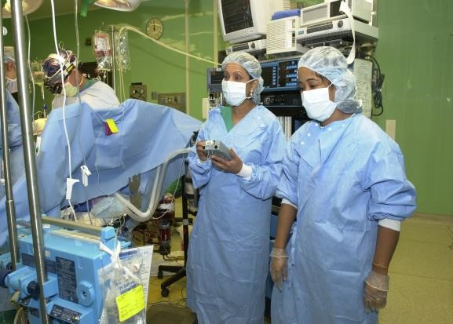
Anesthesia Technologist
This concentration allows students to function as an integral member of an anesthesia team in a surgical setting. After completion of this concentration, students can work as an assistant in the operating room and can continue on to the noncredit post-baccalaureate program at UH in order to be eligible for the national certification examination.

Healthcare Quality: Coding and

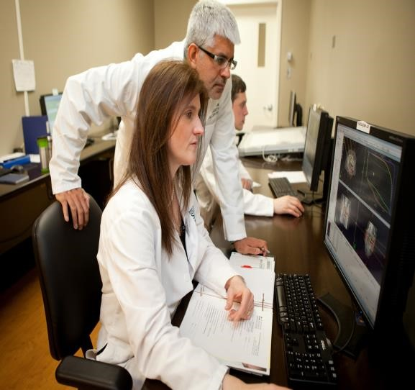
Reimbursement
This concentration is designed to prepare students for entry level practice as a medical coder. Medical coders are specialized technicians who utilize classification systems to help determine the proper diagnosis and procedure codes and utilize computer software to assign one of several hundred “diagnosis-related groups”, or DRGs. The DRG determines the amount for which the hospital will be reimbursed if the patient is covered by Medicare or other insurance programs using the DRG system. In addition to the DRG system, coders use other coding classification systems, such as those geared toward ambulatory settings or long-term care. The data abstracted by the coder is also utilized in analysis and development of quality healthcare initiatives and national health policy.

Medical Dosimetry
A medical dosimetrist is a member of the radiation oncology team. Medical dosimetrists have the education and expertise necessary to generate radiation dose distributions and dose calculations for cancer patients in collaboration with the medical physicist and the radiation oncologist. After completion of this concentration, students continue on to the noncredit post-baccalaureate program at UH in order to be eligible to take the national registry examination. Job opportunities may be found in cancer treatment centers, community hospitals, free-standing clinics and medical schools.
The Medical Dosimetry concentration is accredited by: Joint Review Committee on Education in Radiologic Technology, 20 North Wacker Drive, Suite 2850,Chicago, Illinois 60606-3182. Phone: 312.704.5300
Email: mail@jcert.org
Website: http://www.jrcert.org/

Radiologic Technology
This concentration was developed to train students to meet the growing demand for technologists who image the body through the use of radiation equipment (x-ray technology). As a member of the radiological team, technologists capture images of bones, organs, and blood vessels as prescribed by physicians to assist in the diagnosis of diseases or injuries. After completion of this concentration, students continue on to the noncredit post-baccalaureate program in order to be eligible to take the national registry examination. Job opportunities may be found in hospitals, physicians’ offices, urgent care clinics, diagnostic laboratories and industry.

Overview of Non-Clinical Concentrations

Note: Non-clinical concentrations do not require applications. Class size is limited for certain concentrations. Please note that registration is on a first come, first served basis.

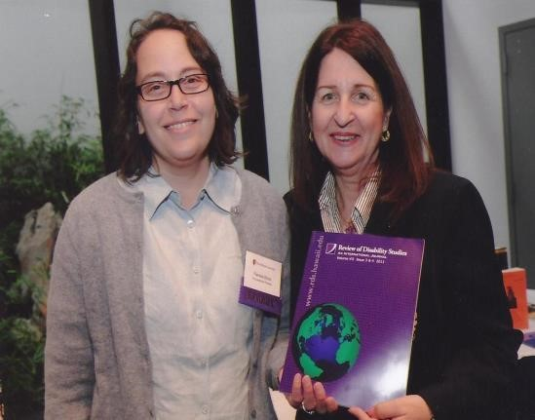
Human Development and Disability Studies
This concentration provides an interdisciplinary focus of study in areas such as independent living, employment, adults and children with disabilities and health and community issues. Moving beyond a medical model of disability, emphasis is placed on overcoming attitudinal barriers and changing social policies to empower this growing minority group. Job opportunities for entry-level professional and managerial positions may be found in the field of human services with organizations for individuals with developmental or physical disabilities, independent living centers, mental health centers and geriatric or vocational rehabilitation agencies.

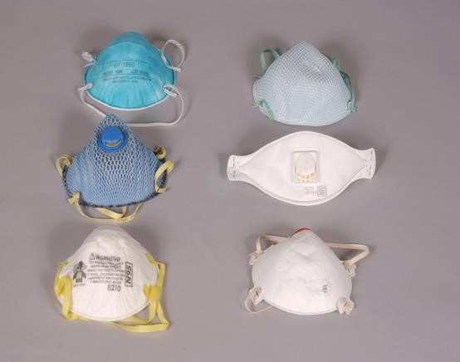
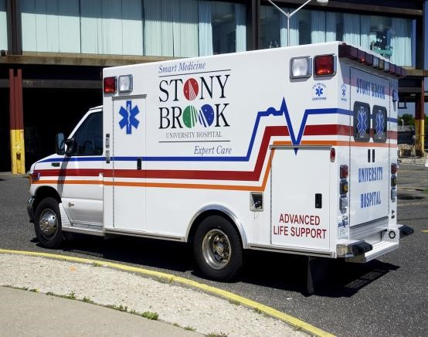
Emergency and Critical Care
This concentration will serve the needs of those students interested in pursuing clinical graduate studies. Emphasis is placed in providing knowledge of the most frequently encountered medical emergencies, including trauma and resuscitation. In addition, due to the changing global environment, courses on hazardous materials and weapons of mass destruction will also be provided.

Environmental Health and Safety
This concentration explores concepts and principles of various health issues regarding quality of life; from the air we breathe, the water we drink and play in, the places we work and live in and anything else that affects our overall well being. Jobs in environmental health can be found in both the public and private sector, ranging from hospitals and other health care facilities, to government agencies such as the Food and Drug Administration, Environmental Protection Agency, town and community water authorities, to private companies such as airlines (food and air quality safety) and laboratories (water quality and ground contamination).

Health Care Informatics
This concentration prepares students for careers in health care information systems, processing and managing health care data with computer and communication technologies. Emphasis is placed on health care information systems’ architecture, computerized medical data processing and clinical decision support systems. Job opportunities may be found in a wide variety of settings, from hospitals and clinics, to software development vendors, the U.S. government and health care consulting firms.
Note: Students must earn the grade of B or higher in HAN 364 to be eligible for the Informatics concentration of study.

Health Care Management
This concentration prepares students with the knowledge and skills to better understand health care practices and utilize the fundamentals of health care management and administration. Job opportunities may be found in hospitals, clinics, physicians’ practices, nursing homes, insurance organizations, public health departments, consulting firms and universities.

Public Health/Community Health Education
This concentration provides a basic foundation in public health, including epidemiology and biostatistics. It also introduces the foundation of planning, implementing and evaluating community-based health education majors. Job opportunities may be found in health departments, public health agencies, HMO’s and other health-related agencies.

Note: Concentrations can be closed without prior notice. Students must then select another concentration of study. Courses within a concentration of study can be changed without prior notice.

Health Science Fall Core Curriculum

HAN 300 Issues in Health Care 3 cr
HAN 333 Communication Skills 3 cr
HAN 335 Professional Ethics in Health Care 3 cr
HAN 364 Health Care Informatics 3 cr
HAN 383 Scholarly Writing in Health Science 3 cr

Fall Electives
Required for students interested in the Radiological Sciences
HAN 395 Radiation Physics in Medicine 4 cr

Required for students interested in Healthcare Quality: Coding and Reimbursement
HAN 424 Pathophysiology for Healthcare 3 cr
Professionals

Note: Students must earn the grade of C or higher in HAN 364 to be eligible to register for the Informatics concentration of study.

Once students have completed fall coursework, they will have a solid foundation to continue on to their spring semester in which they select a concentration of study.

Health Science Spring Curriculum

 | Anesthesia Technology
HAN 434 | Compliance and Regulation 4 cr
HAN 481 | Introduction to Anesthesiology 2 cr
HAN 483 | Cardiopulmonary Physiology for Anesthesia 3 cr  Technology
HAN 485 | Clinical Monitoring 1 cr
HAN 489 | Pharmacology for Anesthesia Technology 4 cr

 | Emergency & Critical Care
HAN 416 | Special Issues in Emergency Care 3 cr and Resuscitation
HAN 417 | Cardiac Emergencies 3 cr
HAN 471 | Trauma and Trauma Systems 3 cr
HAN 472 | Emergency Response to Hazardous Materials 3 cr  and Terrorism
HAN 477 | Medical Emergencies 3 cr

 | Environmental Health and Safety
HAN 470 | Occupational Health and Safety Engineering | 3 cr
HAN 474 | Industrial Hygiene | 4 cr
HAN 475 | Fundamentals of Environmental Health | 3 cr
HAN 476 | Hazardous Materials, Emergency Response and Environmental Auditing | 4 cr
HAN 478 | Internship in Environmental Health | 2 cr

 | Health Care Informatics
HAN 462 | Developing Health Information Systems | 4 cr
HAN 464 | Health Information Systems Management | 4 cr
HAN 466 | Applied Health Care Informatics 3 cr
HAN 467 | Utilization and Outcomes Research Methods 3 cr

 | Health Care Management
HAN 432 | Introduction to Health Care Management | 4 cr
HAN 433 | Statistics for Healthcare Management | 3 cr
HAN 434 | Corporate Compliance and Regulation | 4 cr
HAN 436 | Continuous Quality Improvement in Health Care | 3 cr

Healthcare Quality: Coding and Reimbursement
FALL SEMESTER
HAN 424 | Pathophysiology for Healthcare Professionals |  | 3 cr
SPRING SEMESTER
HAN 418 |  | Basic CPT Coding | 3 cr
HAN 419 |  | ICD-10-CM for Coders | 3 cr
HAN 420 |  | ICD-10-PCS for Coders | 3 cr
HAN 421 |  | Advanced CPT | 3 cr
HAN 422 |  | Coding Healthcare Reimbursement | 3 cr
SUMMER SESSION I
HAN 423 |  | Coding Practicum | 3 cr

 | Human Development and Disability Studies
HAN 443 | Aging and Disability | 3 cr
HAN 446 | Disability Health and Community | 3 cr
HAN 447 | Children with Disabilities | 3 cr
HAN 448 | Disability and Employment | 3 cr
HAN 449 | Project in Disability Studies | 4 cr

 | Public Health/Community Health Education
HAN 440 | Introduction to Community Health Education | 3 cr
HAN 450 | Introduction to Public Health | 3 cr
HAN 452 | Epidemiology and Biostatistics | 3 cr
HAN 455 | Health Literacy for Public Health Students | 3 cr
HAN 456 | Behavioral and Social Aspects of Health | 3 cr

 | Medical Dosimetry
HAN 401  HAN 402 | Radiobiology & Health Physics  Radiographic Anatomy & Pathology | 3 cr  3 cr
HAN 482 | Introduction to Pathology | 3 cr
HAN 487 | Introduction to Treatment Planning | 3 cr
HAN 490 | Fundamentals of Medical Dosimetry and  Contouring | 3 cr
HAN 492 | Radiation Oncology Physics II | 4 cr

Health Science Academic Standards
To be in good standing in the School of Health Technology and Management, a Health Science student must maintain a 2.0 overall cumulative grade point average, with a 2.5 minimum cumulative grade point average in the required professional (prefix HAN) courses. (Refer to Policy on Academic Standing in the Health Science Student Manual.)
- If a student receives a grade less than C in any required Health Science course, s/he is considered to have failed that course.
  - A student is required to retake the failed course during the next academic year.
  - If a student is required to repeat a course due to failure or withdrawal from the course, s/he may need to follow a modified schedule. This modified schedule will change the student’s projected graduation date.
  - A student who fails a HAN course for the second time will be recommended to the dean for termination.
  - If the student fails to maintain a minimum 2.5 cumulative grade point average in the required professional (prefix HAN) courses, s/he will be recommended to the Dean for probation.

- A student must receive a grade of C or higher in a minimum of four core courses in order to advance to the spring 2018 concentration curriculum.
HAN 300 Issues in Health Care
HAN 333 Communication Skills
HAN 335 Professional Ethics in Health Care
HAN 364 Health Care Informatics
HAN 383 Scholarly Writing in Health Science

  - A student who fails one course in the fall 2017 semester will be will be recommended to the dean for probation, and will remain on probation until the course has been successfully completed the following academic year (fall 2018).
  - A student that fails two core courses in the fall 2017 semester will be recommended to the dean for suspension for the spring 2018 and summer 2018 semesters. The student must retake the failed courses the following academic year (fall 2018 semester) and pass all courses to be eligible to register for the spring semester.

- If a student fails a course(s) in the spring 2018 semester, s/he will be recommended to the dean for suspension for the summer and fall 2018 semesters. S/he will be required to return the spring 2019 semester and successfully retake the failed course(s), with the exception of clinical concentrations. If a student fails a course(s) in spring 2018 (Anesthesia Technology, Healthcare Quality: Coding and Reimbursement, Medical Dosimetry, Radiologic Technology), the student will need to return to retake a new non-clinical concentration of student in the spring 2019 spring semester.

Students who have failed only one course during the spring semester, are in good standing, and are not missing any other graduation requirements, may petition the program director (in writing) to switch to the generalist concentration of study. The program director will review petitions on a case by case basis. If the petition is granted, the student will be permitted to complete one course (which has been approved by the program director) during the summer or fall semester enabling the student to be cleared for BS in Health Science degree prior to spring 2019.

A student who is advanced to the Health Science senior curriculum with a condition(s), must satisfy the condition(s) by July 31, 2018. A student, who does not satisfy their condition, will be recommended to the dean for termination.

- A student who wishes to take more than 19 credits, must submit a credit overload petition to the program director and await approval.

Advancing to Senior Year
Once a student is advanced to the Health Science senior year (i.e., when the unofficial transcript under the “program” section states “Bachelor of Science”), s/he becomes an east campus student. All administrative paperwork (e.g., enrollment adjustment, leave of absence, degree dates, financial aid, etc.) is then completed on the east/Health Sciences side of campus. For assistance with any east campus issues, please contact Traci Thompson. (traci.thompson@stonybrook.edu, HSC, Level 2, Room 453). Under special circumstances, the program director, may allow a student to advance to senior year status missing a prerequisite (e.g., DECs, Skills, Stony Brook Curriculum, Health Science prerequisites, and other major requirements, etc.). It remains the students’ responsibility to complete all requirements in a timely manner before May or August graduation.

The ONLY thing that remains the same for both east and west campus students is use of the Bursar’s office for payment issues.

Students must resolve any grades of “Incomplete (“I”) prior to advancing to the senior year. Students that receive a grade of “I” after advancement will be in jeopardy of losing their senior year status.

CITI Training
Completion of two CITI trainings (an assignment in HAN 251) is required for all undergraduate students in the Health Science major. During the first few weeks of the semester you will receive an email only if we do not have documentation of the successful completion of the 2 required CITI trainings below:
Human Subjects Protection in Social and Behavioral Sciences Course (Group 1 SBS)
The Responsible Conduct of Research (RCR) in Social and Behavioral Sciences Course

If you have completed the two required trainings and you receive an email, simply log onto CITI and print new reports. Submit them to either Traci Thompson or Jose Mejia.

If you never completed the training during HAN 251 then you must log on and complete the trainings. Please note that you can only register for one course at a time. Once you complete the first course, you can then register for the second course. If you wish to complete any of the required training for research compliance, navigate to the CITI Program at citiprogram.org, click Log in through My Institution, select SUNY - University at Stony Brook, and log in using your NetID and NetID password. The CITI web-based program is available at http://www.citiprogram.org

If we do not receive documentation of successful completion of the CITI training by October 1st, 2017 a hold will be placed on your account (until documentation is received) that will prohibit you from registering for the spring semester. If you have any questions contact Dr. Zelizer. If you have questions about signing on to CITI, please contact University Information Systems/Research at ovpr-it@stonybrook.edu

Graduation Clearance
Since we are a senior year major, students are expected to be May degree candidates, please note that grades can’t be changed once a degree has been posted to their unofficial transcript. Students have a one-week timeframe after graduation to review spring grades and contact faculty with any questions. Once a student has been cleared for graduation, a grade change can’t be processed for any course.

Minors and Second Majors
The health science program is a full-time senior year major. Therefore, it is expected that once students begin the Health Science senior year curriculum, they will be May degree candidates. It is also expected that any prerequisite coursework needed for graduate programs or for a major or minor will be fully completed prior to the start of the senior year curriculum. Students may not declare a second major or minor once being advanced to the Health Sciences Center as an east campus student without permission of program director.

Time Conflicts
During the senior year, students are permitted to enroll in west campus classes only if there are no conflicts with Health Science course schedules. Under no circumstances will permission for time conflicts greater than ten minutes be considered.

Procedure to request permission for a ten minute time conflict:

- Fill out a Time Conflict form from the west campus Academic Advising office
- Have the west campus faculty person sign form agreeing to the time conflict
- Write a letter stating that if the time conflict is granted, it will not impact on the ability to attend all of the HAN courses since the faculty of the west campus course has given permission to come late/leave early
- Bring signed form and letter to the Health Science Program Director

Note: The Health Science Program Director can approve time conflicts for HAN courses only.

G/P/NC
As previously stated, once a student advances to senior year, s/he is considered an HSC campus student and, therefore, can no longer G/P/NC a course, even if the class is offered on west campus. This also applies to any summer coursework taken after completing senior year curriculum.

Advising/Office Hours
An appointment is recommended when in-depth advising is necessary, so time can be dedicated to addressing specific student questions or concerns.

If a student is experiencing a problem in a course, it is recommended that s/he speaks with the course instructor; also keeping the concentration advisor informed. If the problem cannot be resolved at this level, it is recommended that the student consult the Program Director.

Examination Policy
During examinations, all books and notebooks must be placed face down on the floor. Students are not permitted to talk during exams unless they are given permission from their instructor. Sometimes, an exam will be proctored by a health science staff member who will be responsible for implementing the examination policies of the program. If a student is asked to move seats during an exam, s/he must comply. In addition, the use of programmable calculators is prohibited. All electronic devices (i.e. cell phones, laptops, smart watches, step trackers, etc.) must be turned off and placed in a backpack. If you are found with an electronic device on your person during an exam it will be an automatic charge of academic dishonesty. It is the student's responsibility to make sure that all test questions have been answered prior to leaving the examination area. Students cannot review or make changes to exams once they have left the room in which the examination is being given. If a student arrives late to an exam, they may not be permitted to take the exam. Students are required to return their scantron and test copy.
Only scantron answers will be considered for grading purposes.

Please note: During exams, when you enter the room, please adhere to the following:
- The only items at your desk/table should be pencils, erasers, ID badge, and highlighters (highlighters/pens are permitted only with instructor approval). All cell phones, smart watches, and step trackers must be put either at the front of the room or in your bag/backpack. If you are found with an electronic device (cell phone, smart watch, step tracker, etc.) on your person during an exam it will be an automatic charge of academic dishonesty.
- Once you enter the room there will be no more talking.
- All items (i.e., notes, cell phones, smart watches, step trackers, etc.) must be packed away before you enter the room. Before you take your seat, you must put your pocketbooks, backpacks, etc. at either the side of the room or the front of the room.
- Find your seat number (if applicable).
- Do not turn exam over until you are instructed to (meaning, do not start filling out scantron, etc.)
- Other information. If you are wearing a ball cap, the brim must be turned to 6 o’clock; if you wish to bring a drink to your seat it will be permitted, but the faculty might ask to inspect the bottle/container; once the exam starts a student will not be permitted to leave the room and return (i.e., go to the rest room and then return to exam).

Grading Scale
A (100 – 95) |  | A- (94-90)
B+ (89-87) |  | B (86 -83) |  | B- (82-80)
C+ (79-77) |  | C (76-73) |  | C- (72-70)
D+ (69-67)  F (< 60) |  | D (66-60)

Course Waivers/Challenge by Credit Exam
Students must receive permission of program director to waive or challenge a course.

Students may petition to obtain credit by challenge exam for a maximum of one course per semester. Students interested in pursuing credit by challenge exam must initiate the request during the first two weeks of the semester in which the course is offered. All requests must be in writing to the Program Director (see SHTM Student Handbook for further details).

Classroom Policies*
- Respect for the instructor and fellow students throughout class is expected.
- Students must be on time.
- Cell phones ringers must be set to vibrate only.
- Individual instructors may prohibit food, electronic devices, etc. Please check with instructor as to their individual policy.
- As per instructor’s rules, students may be permitted to use their laptops or other electronic devices during classroom time for academic purposes only. Checking email, surfing the web for entertainment purposes is not permitted. Failure to adhere to this policy will result in the laptop being placed in the front of the room until the class has ended.
- Professional behavior, as defined in a subsequent section of this manual, is required. Students must conduct themselves accordingly.

* Individual faculty members may determine additions to, and variations from, these standards for each class.

Participation and Attendance Policy
The Health Science faculty believes in the importance of attendance at all classes. Learning communities require that students are actively engaged in collaborative learning. This leads to a deeper understanding of course content and fosters the development of skills. To that end, participation in every HAN course is mandatory. If a student is absent they lose the opportunity to participate in required learning activities, such as, group projects and activities and class discussions. As such, absences will negatively impact your participation grade. It is recognized that from time to time students may need to be absent from a class. Students are responsible for learning any educational information missed during any absence.

Religious Holidays
Students who are absent from class because of religious holidays and are therefore unable to take a midterm or final examination must, by law, be given an opportunity to take the examination at another time. Students should fill out an excused absence form. Assignments for excused absences due to a religious holiday are due prior to the absence. Students who received an excused absence will be able to take makeup exams on Fridays. Please e-mail Jose Mejia (jose.f.mejia@stonybrook.edu) to schedule the makeup exam. Note: makeup exams can be given in an alternative format.

Excused Absences

Procedure to Request an Excused Absence: (Course instructors are not permitted to grant excused absences. Students must follow the guidelines below if a they want the absence to be reviewed and excused.)

- Fill out Excused Absence Petition form located on the table outside of HSC, Level 2, room 453.
- Submit form and documentation to Jose Mejia.
- Excused absence petitions must be submitted to Jose Mejia, room 2-472 either 1) one week prior to planned absence (i.e., court appearance, doctor visit, religious holiday, etc.) or 2) no later than one week after an emergent absence (i.e., death in family, surgery, car accident, etc.). If an assignment is due on the date of a planned absence it must be submitted prior to the absence.
Failure to follow this procedure will result in denial of the petition and negatively impact class
attendance. Excused absences for personal reasons (i.e., wedding, vacations, etc.) will not be considered.
- Students are allowed to request two absences per semester. Any circumstances exceeding this must be discussed with the program director. In certain circumstances a formal Leave of Absence may need to be filed.
- Petition forms will not be considered without proper documentation.
- If the petition is approved the department will contact the instructor via email.
- If the petition is denied the student will be notified.

Students who receive an excused absence will be able to take makeup exams on Fridays. Please e-mail Jose Mejia (jose.f.mejia@stonybrook.edu ) to schedule the makeup exam.

Note: An excused absence does not excuse student from making up coursework and may impact the participation grade. Makeup exams for an excused absence can be given in an alternative format.

Procedures to Insure Compliance:

- Faculty will keep attendance records. It is at the discretion of the instructor regarding the frequency in which attendance will be assessed. For example, an instructor might retake attendance after break without prior warning.
- Students must provide the appropriate documentation for absences from examinations due to medical and/or family emergencies with their submitted petition.
- Any unexcused absence may result in an adjustment (decrease) of the final grade for that course.

Note: Signing a handwritten attendance sheet or submitting attendance electronically (ex. clickers) for another student is an act of academic dishonesty and will result in disciplinary action.

Privacy of Course Material
When participating in social electronic communication (i.e. Twitter, You Tube, Facebook, Course Hero, Email, Quizlit, Chegg, Study Blue, Text Messaging, etc.):

- A student assumes total responsibility for the content (photos, comments, videos, etc.)
and monitoring.
- Students are prohibited from photographing or video or audio recording any part of a
Health Science coursework unless they have permission from the course instructor.
- All academic materials (exams, assignments, student projects and presentations, case
studies, lectures, etc.) are confidential and must not be disseminated in anyway unless
the student receives approval from the department chairperson in writing.

Academic Integrity
This syllabus statement applies to every HAN course in the major.
Academic integrity is the foundation of instruction, research and genuine learning. Faculty and students have the responsibility to maintain the highest levels of academic integrity for themselves and for the University. SBU regards acts of academic dishonesty as serious offenses against the educational community and the quality of scholarship, defrauding those who depend upon its integrity. The statement below applies to every course in the Health Science major.

Each student must pursue his or her academic goals honestly and be personally accountable for all submitted work. Representing another person's work as your own is always wrong. Faculty is required to report any suspected instances of academic dishonesty to the Academic Judiciary. Faculty in the Health Sciences Center (School of Health Technology & Management, Nursing, Social Welfare, Dental Medicine) and School of Medicine are required to follow their school-specific procedures. For more comprehensive information on academic integrity, including categories of academic dishonesty please refer to the academic judiciary website at http://www.stonybrook.edu/commcms/academic_integrity/index.html

Since this is a HAN course, you will be held accountable to the academic dishonesty
policies and procedures of SHTM. Please review the policies posted at

https://healthtechnology.stonybrookmedicine.edu/sites/default/files/2015%20SHTM%20 Handbook%20for%20BSHS_1.pdf

Professional Behavior

Performance Skills and Attitudes - Assessment Procedures

In addition to mastery of cognitive skills and knowledge, students will be evaluated on their performance skills and attitudes. These include the following:

- adherence to the University Code of Conduct
- ability to work with and relate to peers, faculty and other members of the health care team ➢ attitude
- attendance and punctuality
- appearance and professional demeanor

Successful completion of each course requires that students continuously maintain high standards. Regardless of the level of achievement in cognitive skills and knowledge, if professional behavior is not appropriate, students may not meet minimum requirements for successful completion of the course.

Unsatisfactory Performance Skills or Attitudes
Unsatisfactory behavior such as disruption of class activities, expression of derogatory, disrespectful remarks to the instructor, other faculty, students or staff, inability to work with peers, or excessive unexcused absences may be cause for warning or further action.
A student who has exhibited unsatisfactory behavior that may affect his or her final evaluation and academic standing shall receive a written warning that stated behavior may jeopardize successful completion and lead to failure of the course.
The details of these policies and procedures can be found in the Academic Standing Policy of the School of Health Technology and Management posted on the Health Science website. (http://healthtechnology.stonybrookmedicine.edu/programs/hs/information)
In addition, all students are expected to adhere to the University's Student Conduct Code.

Critical Incident Management
This syllabus statement applies to every HAN course in the major.

Stony Brook University expects students to respect the rights, privileges, and property of other people. Faculty are required to report to the Office of University Community Standards any disruptive behavior that interrupts their ability to teach, compromises the safety of the learning environment, or inhibits students' ability to learn. Faculty in the HSC Schools and the School of Medicine are required to follow their school-specific procedures. Further information about most academic matters can be found in the Undergraduate Bulletin, the Undergraduate Class Schedule, and the Faculty-Employee Handbook.

Records Review
Students are responsible for reviewing their own academic profile on a regular basis to ensure that they have met all the requirements for graduation. Students who are unsure of their status should meet with a Health Science advisor for an academic profile review. Program files are confidential. Students may request file material from their advisors.

FERPA/Access to Student Records
Directory information (i.e., name, date of birth, major, class, dates of attendance, degrees, etc.) is available to the public upon request through the Registrar's Office. Students who wish to have their directory information suppressed from public view must file a request at the Registrar's Office using the Request to Suppress/Release Directory Information Form.
Students' academic records are private and confidential according to the Family Educational Rights and Privacy Act (FERPA). If you wish to grant access of your academic records (grades) to your parent or guardian, you must submit a notarized FERPA form to the Registrar's Office. Blank forms may be obtained by visiting the Registrar’s office during regular operating hours. You may also access some forms online.

Student Information and Data
The Health Science Department will have many instances throughout the academic year when students will need to be notified about situations requiring their immediate attention. Most often, this contact will be made through the student’s e-mail address or Blackboard. Occasionally, notifications may be sent to the address listed on the student’s University records. Therefore, it is imperative that the office be aware of a student’s current addresses, both local and permanent, as well as, the student’s telephone numbers and e-mail addresses. Please notify the office of any changes in this information as soon as possible.

Office Policy
Students may not use SHTM faxes, phones, photocopiers or any office equipment.

Student Officers and Representatives
Students are given the opportunity to either self-nominate in elections, or volunteer to serve in roles such as:

- Health Science Class Officers
- Dean’s Advisory Committee Representative
- Health Sciences Center Student Association Representative (HSCSA)
- Other committee representatives, as needed

Disability Support Services (DSS)
The office of Disability Support Services (DSS) provides assistance and coordinates advocacy and support services for students and employees with disabilities. Assuring campus accessibility, assisting with academic accommodations and providing assistive devices are important components of its programs. DSS is located on West campus in the Educational Communications Center, Room 128, 631.632.6748 (voice and TT).
http://studentaffairs.stonybrook.edu/dss/index.html

Americans with Disabilities Act
This syllabus statement applies to every HAN course in the major.
If you have a physical, psychological, medical or learning disability that may impact your course work, please contact Disability Support Services, ECC (Educational Communications Center) Building, Room 128, (631)632-6748. They will determine with you what accommodations, if any, are necessary and appropriate. All information and documentation is confidential.
http://studentaffairs.stonybrook.edu/dss/

If a student has a physical, psychological, medical or learning disability that may impact course work, s/he can contact DSS to discuss accommodations. DSS will determine what accommodations are necessary and appropriate. All information and documentation is confidential.

Testing Accommodations for Students with Disabilities
Faculty members are required to provide academic accommodations. DSS is available to assist in that process. Students with documented disabilities who need accommodations when taking examinations should contact DSS. Once documentation has been approved, DSS will advise the faculty member of the accommodation to which the student is entitled. Readers, scribes and proctors, as well as, the use of a computer and/or other assistive devices can be provided. Students must make the necessary arrangements with both faculty and DSS in a timely manner according to DSS guidelines. Please request that the accommodation letter be sent to the program director and Jose Mejia as the department plays a direct role in the facilitation of your accommodation.

Financial Aid
Contact the HSC Office of Student Services for financial aid questions. 631-444-2111, Health Sciences Center, Level 2, Room 271.

Academic Calendar
The fall 2017 academic calendar can be accessed by visiting the following website: http://www.stonybrook.edu/commcms/registrar/calendars/_acalcontent/ay1718/Ugrd%20Fall%202017%203.10.17.pdf

Tuition Website
Tuition rates can be accessed by visiting the following web page: http://www.stonybrook.edu/bursar/tuition/tuition-and-fee-rates.shtml
Tuition rates for the Health Sciences major’s certificate programs can be accessed by visiting the following we page:
http://www.stonybrook.edu/bursar/tuition/professional/htm.shtml

E-mail/Blackboard Account
Students should check their “stonybrook.edu” e-mail and Blackboard accounts on a daily basis to remain current on what is happening in the program. Correspondence is often sent via
“stonybrook.edu” e-mail or through Blackboard which requires prompt attention (e.g., requests for meetings with faculty, graduation notices, classroom changes etc.). Failure of a student to check his/her “stonybrook.edu” e-mail account will not be accepted as an excuse for missing any deadlines that may come with the notices.

Blackboard accounts are to be used exclusively for academic purposes. Students are not permitted to use or share class distribution lists to promote non-academic endeavors (e.g., fundraisers, social or religious events, etc.)

Health Science Bulletin Board
The health science bulletin board is located outside Room 452, L2, HSC. It is recommended that students check the bulletin board regularly for announcements, department activities, job opportunities, etc.

Room Assignments
Room assignments for all courses will be posted on the bulletin board outside of Room 452, Level 2.

Inclement Weather
Classes at the University are only cancelled under extraordinary circumstances. Cancellation of classes or alteration of work schedules for non-essential employees are announced by the Office of the President following consultation among the President, the Vice President for Administration and other campus officers. The Governor of New York is the only official authorized by law to close the University.
Students are to assume classes are in session unless the University cancels classes. This information can be obtained by calling 631.444.SNOW.
NOTE: Announcements will also be made on radio stations on Long Island and in New York City, including WABC (770 AM), WALK (1370 AM, 97.5 FM), WBLI (106 FM), WINS (1010 AM), WNBC (660 AM), and WUSB (90.1 FM).

If an individual instructor needs to cancel class due to weather conditions, please check the class Blackboard account for faculty announcements.

SHTM Security Issues
All doors to SHTM offices are locked at 5:00 p.m. Students are not allowed access to the area after that time unless they have an appointment with faculty or staff. Doors open at 9:00 a.m.

Emergency Management: Evacuation Guidelines & Planning
To report an emergency, dial 911, from a University phone, to connect with University Police (on campus) and Suffolk County Police Departments (off campus). https://ehs.stonybrook.edu/programs/fire-safety/emergency-evacuation-during-fire

Information for students with disabilities who may require emergency evacuation is in the Americans with Disabilities Act section of this manual.

University Police
The University Police department is located on the 3rd floor of the Health Sciences Center. The department is committed to assisting members of the campus community and to enforcing the law in a humane and constitutional manner. University police officers have full police powers in the performance of their duties and have the same responsibilities as other New York State law enforcement officers. University police officers enforce campus parking regulations as well as vehicle and traffic law regulations. A radio network through the department’s communications room connects all campus emergency equipment. Vehicle, bike and foot patrols are radio equipped and are dispatched to respond to all incidents reported to the department. For general information: 631.632.7786.

Residential Safety Patrol - Walk service is student-operated and is available to anyone on campus between the hours of 8:00 pm and 3:00 am.

EMERGENCY PHONE NUMBERS: On campus – 911
Off campus- 631.632.3333

SB Alert
SB Alert is a comprehensive emergency notification system used to alert members of the campus community about major emergencies, immediate threats or impending situations that can pose harm to individuals, disrupt classes or impact facilities, activities or other operations. When activated, the system sends a voice, alphanumeric page, email and/or text message to ALL the devices entered into the SB Alert-Contact Information section.

Enrollment is not automatic. Individuals must register for the program on SOLAR. To find out more about SB Alert, to register or to elect not to receive emergency notifications:
http://www.stonybrook.edu/commcms/emergency/alerts/alerts.html

FAILURE TO ENROLL WILL RESULT IN A NEGATITVE SERVICE INDICATOR ON YOUR SOLAR ACCOUNT.

Please note that cell phone providers may charge fees for delivery of text messages based on current calling plans. Bear in mind, those messages are sent only when there is a real emergency. The benefit of receiving vitally important safety information will far outweigh the cost of a text message.

Register for SB Guardian System
SB Guardian is frequently referred to as a “personal blue light phone” in your pocket. The features of the Guardian system will significantly enhance the safety of all students, faculty and staff on campus. Although we strongly recommend enrolling in the SB Guardian system, its use and enrollment are strictly voluntary. The system functions in two primary ways:

Panic Call Mode – With this feature you can program the Guardian phone number into a designated speed dial, allowing a one touch call that will automatically notify University Police. If your phone utilizes smart technology and has a GPS capability, the panic call will also indicate your location on campus, thereby facilitating faster response by police or other emergency responders. You also have the option to add additional information to the database including your vehicle information, allergies, or other special considerations emergency responders should be aware of when responding. Precautionary Timer Mode – With this feature, you can set a time that coincides with the time you expect to travel from one location on campus to another. If you arrive safely and deactivate your timer, University Police will never receive notification that a timer was ever set. If you do not deactivate your timer, you will receive a text message from the system three minutes prior to its expiration and a phone call one minute prior to its expiration to alert you to deactivate your timer. If you do not reach your destination, or are otherwise detained, the timer will automatically trigger a panic call to the University Police who will then be able to respond to your location.

Fire Alarm Signals
The HSC Building fire alarm systems use a signaling device to alert occupants of the need to evacuate for fire or other reasons.

HSC Floors 1-5: Only the floor in alarm must evacuate. The following voice message will be heard:
*Sirens* "May I have your attention. May I have your attention please? A fire alarm has been reported in your area. Please evacuate the area using the nearest exit or stairway. Do not use the elevators." *Sirens*
All other floors in the building will hear an alert tone and the following voice message: *Alert Tone* "May I have your attention. May I have your attention please? There has been a fire alarm reported in another area of the building. Please stay in place and await further instructions." *Alert Tone *

Please contact the Department Chair if you have any questions and/or concerns.

Counseling and Psychological Services

Located at Student Health Services, Second Floor
Stadium Road
Stony Brook, NY 11794-3100 • across from H Quad.
- wheelchair accessible, elevator to 2nd floor.
- parking available next to the SHS building.

IN AN EMERGENCY
During office hours:
CALL 631-632-6720 OR GO TO THE CENTER. Tell the receptionist that this is an emergency.
After hours:
Students can now call CAPS and speak to a licensed mental health counselor anytime, day or night. To do so, call CAPS at (631) 632-6720; If it is after regular business hours, press 2 to speak with a counselor.
Students can also contact CAPS After Hours directly 24/7 at (855) 509-5742. You will be connected with a licensed mental health counselor who is familiar with our campus community and local resources.
Call the University Police at 911 from a campus phone or 631-632-3333 from a cell phone or if you are off campus.
Go to the Stony Brook Hospital Emergency Room on Health Sciences Drive.
Call the Psychiatry ER at 631-444-6050.

Sexual Assault
If you are a victim of a rape or sexual assault, seek medical attention immediately. Call University police on campus at 911 or 631-632-3333 from a cell phone or off campus, or, if the rape/sexual assault occurs off campus, the local police at 911. University Police can provide transportation to the hospital.
The Victims Information (VIBS) at 631-360-3636 can advise you about options available and can offer an advocate to provide support for you at the hospital and afterward.
Additional information can be found at the Center For Prevention and Outreach and the Wo/Men’s and Gender Resource Center.
The Wo/Men's and Gender Resource Center is in Room 216 in the Student Union, Monday through Thursday 10-6 p.m. and Friday 10 to 4 p.m. Please call 2-WOMN (632-9666) for an appointment.

Sexual Harassment
Stony Brook University is committed to creating and maintaining workplace, educational, and recreational environments that are safe and accessible, and free of all forms of discrimination, discriminatory harassment and sexual harassment, including non-consensual sexual contact, sexual violence, domestic violence, and stalking. Such behavior is prohibited and violates Title VII of the Civil Rights Act of 1964 and Title IX of the Education Amendments of 1972.

- Sexual Harassment is unwelcome sexual advances, requests for sexual favors and verbal or physical or communicative (verbal, non-verbal and electronic) conduct of an abusive sexual nature constitute harassment when such conduct interferes with an individual’s work or academic performance, or creates and intimidating, hostile, or offensive work or academic environment. Harassment of employees by supervisors or of students by faculty or administration is unlawful and may result in sanctions, as permitted. Conversely, harassment of supervisors by employees, faculty by students, or individuals by co-workers violates University policy and practice.
- The University is responsible for and fully committed to the prevention and elimination of sexual harassment. All members of the campus community are responsible for fostering an atmosphere that promotes equity, civility, caring, responsibility, accountability, and respect.
- The University does not tolerate sexual harassment and treats it as a form of misconduct, which is handled in accordance with the University’s discrimination complaint procedure. Sanctions enforced against individuals engaged in such behavior will follow Labor Management process and procedures if the respondent is a faculty or staff member or will be address through Community Standards if the named individual is a student.

The professionally trained staff in the Office of Diversity and Affirmative Action (ODAA) investigates and makes recommendations on allegations of sexual harassment. Individuals who are affected by or are aware of suspected cases of sexual harassment are urged to bring such situations to the University’s attention by contacting the ODAA. Any person who believes that s/he has been subjected to sexual harassment or has any questions regarding the University's policy or procedure is invited to contact the ODAA at 631.632.6280.

Discrimination
Stony Brook University prohibits unlawful discrimination and harassment on the basis of race, sex, age, color, religion, national origin, sexual orientation, disability, marital status or status as a disabled or Vietnam-era veteran in the implementation of any of its policies, procedures or practices regarding the terms, conditions, and privileges of employment for students, faculty, and staff. This nondiscrimination policy affects all employment practices including, but not
limited to, recruitment, hiring, transfers, promotions, benefits, compensation, training, educational opportunities and terminations.

Should any person believe that he or she has been discriminated against, has been subjected to sexual harassment or has any questions regarding the University's policy or procedure, please contact the Office of Diversity and Affirmative Action (ODAA) at 631.632.6280.

Health Sciences Library
The Health Sciences Library (631.444.2512), located on Level 3, serves faculty, staff and students. Orientation to the library, the online catalog and networked resources are provided by the reference staff. Please feel free to ask for assistance. The HSC library only lends materials to those holding HSC library cards. http://www.library.stonybrook.edu/healthsciences

Banking Services
For the convenience of employees and students, several banking facilities are available throughout campus.

Island Federal Credit Union

Locations:
- HSC - 2nd Level (631.851.1100)
- Student Activities Center – Lower Concourse (631.851.1100)

Automated Teller Machines (ATM) provide 24 hour, 7 days a week banking convenience.

West campus ATM units are located at:
- Administration Building
- Sports Complex
- Dental School
- Stony Brook Union
- Student Activities Center
- West Dining Hall

East campus ATM units are located at:
- Level 2 of the Health Sciences Center
- Level 5 of the Health Sciences Center (as of publication ATM at this location is not Island Federal Credit Union operated)

Book Store
Amazon is the official bookstore. This convenient online experience will offer more opportunities for students to save on overall costs of course materials.

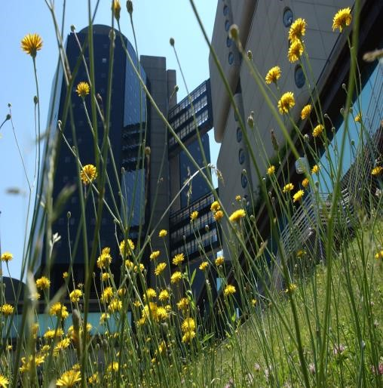

Comments regarding this manual are always welcome. Suggestions can be sent to Jose.f.mejia@stonybrook.edu

The information provided in this manual is a general description of the Health Science major at Stony Brook University. Certain requirements and characteristics of course offerings are subject to change due to emerging developments. The Health Science Program reserves the right to amend any typographical errors that may have occurred in the compilation of this handbook. Students are encouraged to contact the Program Director with any concerns or discrepancies.

This publication can be made available in an alternative format upon request.

Stony Brook University is an equal opportunity/affirmative action educator employer. ©2017

